**Calculator1/ Calculator12**

**activity_main.xml**

*<?***xml version="1.0" encoding="utf-8"***?>*<**LinearLayout xmlns:android="http://schemas.android.com/apk/res/android"  
 xmlns:tools="http://schemas.android.com/tools"  
 android:id="@+id/activity_main"  
 android:layout_width="match_parent"  
 android:layout_height="match_parent"  
 android:orientation="vertical"  
 android:paddingBottom="@dimen/activity_vertical_margin"  
 android:paddingLeft="@dimen/activity_horizontal_margin"  
 android:paddingRight="@dimen/activity_horizontal_margin"  
 android:paddingTop="@dimen/activity_vertical_margin"  
 tools:context="com.sarker.mms.calculator1.MainActivity"**>  
  
 <**EditText  
 android:layout_width="match_parent"  
 android:layout_height="wrap_content"  
 android:inputType="number"  
 android:textSize="25sp"  
 android:hint="Number 1 :"  
 android:ems="10"  
 android:id="@+id/Number1"** />  
  
 <**EditText  
 android:layout_width="match_parent"  
 android:layout_height="wrap_content"  
 android:inputType="number"  
 android:textSize="25sp"  
 android:hint="Number 2 :"  
 android:ems="10"  
 android:id="@+id/Number2"** />  
  
 <**TextView  
 android:text="Result : "  
 android:textSize="25sp"  
 android:layout_width="match_parent"  
 android:layout_height="wrap_content"  
 android:id="@+id/Result"** />  
  
 <**Button  
 android:text="Add"  
 android:layout_width="match_parent"  
 android:layout_height="wrap_content"  
 android:id="@+id/Add"** />

<**Button  
 android:text="Substract"  
 android:layout_width="match_parent"  
 android:layout_height="wrap_content"  
 android:id="@+id/Substract"** />  
  
 <**Button  
 android:text="Multiply"  
 android:layout_width="match_parent"  
 android:layout_height="wrap_content"  
 android:id="@+id/Multiply"** />  
  
 <**Button  
 android:text="Divide"  
 android:layout_width="match_parent"  
 android:layout_height="wrap_content"  
 android:id="@+id/Divide"** />  
</**LinearLayout**>

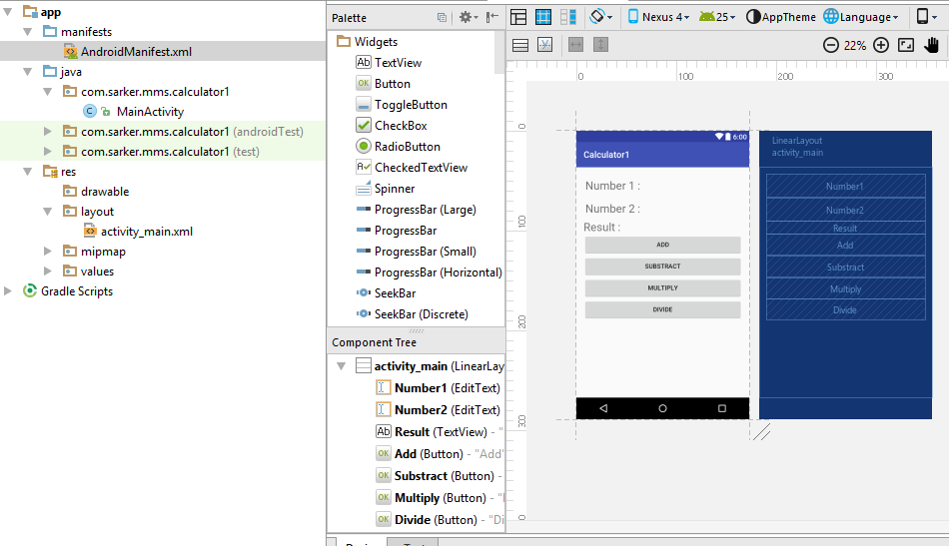

**MainActivity.java**

**package** com.sarker.mms.calculator1;  
  
**import** android.support.v7.app.AppCompatActivity;  
**import** android.os.Bundle;  
**import** android.view.View;  
**import** android.widget.Button;  
**import** android.widget.EditText;  
**import** android.widget.TextView;  
  
**public class** MainActivity **extends** AppCompatActivity {  
  
 TextView **Result**;  
 EditText **Number1**, **Number2**;  
 Button **Add**, **Substract**, **Multiply**, **Divide**;  
 **float result_num**;  
 **int num1**, **num2**;  
  
 @Override  
 **protected void** onCreate(Bundle savedInstanceState) {  
 **super**.onCreate(savedInstanceState);  
 setContentView(R.layout.***activity_main***);  
 **Result** = (TextView)findViewById(R.id.***Result***);  
 **Number1** =(EditText) findViewById(R.id.***Number1***);  
 **Number2** =(EditText) findViewById(R.id.***Number2***);  
  
 **Add** = (Button)findViewById(R.id.***Add***);  
 **Substract** = (Button)findViewById(R.id.***Substract***);  
 **Multiply** = (Button)findViewById(R.id.***Multiply***);  
 **Divide** = (Button)findViewById(R.id.***Divide***);  
  
 **Add**.setOnClickListener(**new** View.OnClickListener() {  
 @Override  
 **public void** onClick(View v) {  
 **num1** = Integer.*parseInt*(**Number1**.getText().toString());  
 **num2** = Integer.*parseInt*(**Number2**.getText().toString());  
 **result_num** = **num1** + **num2**;  
 **Result**.setText(String.*valueOf*(**result_num**));  
 }  
 });  
 **Substract**.setOnClickListener(**new** View.OnClickListener() {  
 @Override  
 **public void** onClick(View v) {  
 **num1** = Integer.*parseInt*(**Number1**.getText().toString());  
 **num2** = Integer.*parseInt*(**Number2**.getText().toString());  
 **result_num** = **num1** - **num2**;  
 **Result**.setText(String.*valueOf*(**result_num**));  
 }  
 });  
 **Multiply**.setOnClickListener(**new** View.OnClickListener() {  
 @Override  
 **public void** onClick(View v) {  
 **num1** = Integer.*parseInt*(**Number1**.getText().toString());  
 **num2** = Integer.*parseInt*(**Number2**.getText().toString());  
 **result_num** = **num1** * **num2**;  
 **Result**.setText(String.*valueOf*(**result_num**));  
 }  
 });  
 **Divide**.setOnClickListener(**new** View.OnClickListener() {  
 @Override  
 **public void** onClick(View v) {  
 **num1** = Integer.*parseInt*(**Number1**.getText().toString());  
 **num2** = Integer.*parseInt*(**Number2**.getText().toString());  
 **result_num** = **num1** / **num2**;  
 **Result**.setText(String.*valueOf*(**result_num**));  
 }  
 });  
 }  
}

**AndroidManifest.xml**

*<?***xml version="1.0" encoding="utf-8"***?>*<**manifest xmlns:android="http://schemas.android.com/apk/res/android"  
 package="com.sarker.mms.calculator1"**>  
  
 <**application  
 android:allowBackup="true"  
 android:icon="@mipmap/ic_launcher"  
 android:label="@string/app_name"  
 android:supportsRtl="true"  
 android:theme="@style/AppTheme"**>  
 <**activity android:name=".MainActivity"**>  
 <**intent-filter**>  
 <**action android:name="android.intent.action.MAIN"** />  
  
 <**category android:name="android.intent.category.LAUNCHER"** />  
 </**intent-filter**>  
 </**activity**>  
 </**application**>  
  
</**manifest**>

